DATA SCIENCE WITH PYTHON
Data Acquisition, Cleaning, and Preprocessing
A defensible cleaning workflow for provisional COVID-19 mortality counts
━━━━━━━━━━━━━━━━━━━━━━━━━━━━━━━━━━━━━━━━━━━━━━━
WEEK | 1
DATE | 7 August 2026
DATASET | Provisional COVID-19 Deaths by Sex and Age

Student name | Mandal Sahil Naushad
Institution | YuvaIntern
Public-use aggregate mortality data • Reproducible Python workflow

Report map
The document follows the required submission structure. Major sections are separated visually and use Word heading styles for navigation.
- 1. Title Page
- 2. Introduction
- 3. Dataset Overview
- 4. Methodology
- 5. Python Code Sections
- 6. Results and Findings
- 7. Visualizations (described in text)
- 8. Challenges and How They Were Handled
- 9. Discussion
- 10. Conclusion
- 11. References

2. Introduction
This report documents how I acquired, inspected, cleaned, and prepared the CDC dataset Provisional COVID-19 Deaths by Sex and Age. The question is not simply whether blank cells exist; it is whether each blank, unusual value, and aggregate row can be interpreted correctly before the data are used for trends, clustering, or prediction.
I selected the dataset because it is a large public-health table from the National Center for Health Statistics, it mixes monthly, yearly, and cumulative records, and it contains privacy-driven suppression. Those features make it a realistic cleaning task: an apparently simple decision such as filling missing counts with zero would alter the signal and could understate mortality in smaller jurisdictions and age groups.
The practical problem answered here is: how can the 137,700-row source file be converted into an analysis-ready table without inventing death counts, double-counting overlapping age groups, deleting valid high-burden jurisdictions, or leaking a partial reporting period into later work?
Scope decision. The source is frozen as of 27 September 2023 and covers deaths through 23 September 2023. The work treats it as a historical public-use file, not as a source of current 2026 COVID-19 surveillance.

3. Dataset Overview
The Data is from the CDC/NCHS public dataset. It contains 137,700 records and 16 source columns. The observation grain is a combination of reporting period, jurisdiction, sex, and age group; it is not one row per person.
Dimension | Observed values | Interpretation
Reporting group | By Month (123,930); By Year (11,016); By Total (2,754) | Three grains are stacked in one file.
Jurisdiction | 54 | 50 states plus DC, Puerto Rico, New York City, and United States.
Sex | 3 | All Sexes, Female, Male.
Age group | 17 | Contains overlapping schemes such as 0–17, 18–29, 30–39 and 15–24, 25–34, 35–44.
Count measures | 6 | COVID-19, all-cause, pneumonia, overlap, influenza, and combined P/I/C counts.
Data coverage | 1 Jan 2020–23 Sep 2023 | September 2023 and the 2023 annual record are partial.
Table 1. Structure of the attached source file.
All source columns arrived as text when loaded defensively. The six count fields contain comma-formatted numbers, and three showed mixed-type warnings under default inference. Year and Month also contain blanks that are structurally correct for cumulative and annual records.

Field | Missing count | Missing % | Decision
COVID-19 Deaths | 39,430 | 28.63% | Retain as unknown; add suppression flag.
Total Deaths | 19,509 | 14.17% | Retain as unknown; do not use as a zero denominator.
Pneumonia Deaths | 44,864 | 32.58% | Retain as unknown; add suppression flag.
Pneumonia and COVID-19 Deaths | 36,884 | 26.79% | Retain as unknown; add suppression flag.
Influenza Deaths | 26,688 | 19.38% | Retain as unknown; add suppression flag.
Pneumonia, Influenza, or COVID-19 Deaths | 44,233 | 32.12% | Retain as unknown; add suppression flag.
Table 2. Missingness in the six measure columns.

4. Methodology
The steps below follow the Week 1 brief in order. Each action includes the reason for doing it and the effect it has on later analysis.

Step 1 — Acquire from a reliable public source
I used the excel sheet and checked its title, column schema, update date, and publisher against the CDC Socrata record. This matters because similarly named CDC tables exist at weekly and monthly grains. The identifier 9bhg-hcku matches the 16-column file used here. A SHA-256 checksum would be recorded in a production run so that the exact input can be reproduced.

Step 2 — Inspect before converting
The first pass loaded every field as text. That is deliberate: automatic type inference can silently interpret comma-formatted counts as strings in one chunk and numbers in another. I profiled shape, unique categories, null counts, date examples, duplicates, and the relationship between Group, Year, and Month before changing values.

Step 3 — Standardize names and data types
Column names were converted to snake_case so the code is consistent and typo-resistant. Dates were parsed with the explicit month/day/year format. Commas were removed only from the six known count columns, after which conversion used a nullable numeric type. Year and Month use pandas nullable integers so their structural blanks remain valid.

Step 4 — Classify missingness instead of treating every blank alike
The count blanks are censored values, not confirmed zeros. Every observed missing count occurs on a footnoted row, and the footnote says counts from 1 to 9 have been suppressed. I therefore preserved NaN and created one Boolean suppression flag per measure. By contrast, Year is correctly blank for 2,754 By Total rows, and Month is correctly blank for all 11,016 By Year plus 2,754 By Total rows. Those structural blanks require no repair.

Step 5 — Check inconsistencies and erroneous entries
I tested duplicate rows, duplicate grain keys, negative counts, impossible date order, COVID-19 counts greater than all-cause deaths, overlap counts greater than either component, and combined P/I/C counts below their component maximum. Every one of these checks returned zero violations. This is stronger evidence than relying on a summary table because it tests the relationships the variables must satisfy.

Step 6 — Detect outliers at a coherent grain
An IQR rule was applied only to cumulative, All Sexes, All Ages jurisdiction rows, after excluding the United States and the overlapping New York City geography. The upper cutoff was 60,705.625 COVID-19 deaths and flagged California, Florida, and Texas. I kept them. Their large counts are plausible consequences of population size and pandemic burden, not typographical errors. Deleting them would remove the jurisdictions that contribute the most deaths and distort every later model.

Step 7 — Prevent aggregation errors
The file includes totals alongside components and two overlapping age-band systems. I created a canonical mutually exclusive age sequence for later analysis: Under 1, 1–4, 5–14, 15–24, 25–34, 35–44, 45–54, 55–64, 65–74, 75–84, and 85+. Summations must also filter one Group and one Sex level. This decision prevents double-counting without deleting useful alternative bands from the clean master table.

Step 8 — Mark partial periods and export with an audit trail
Rows for September 2023 monthly data and 2023 annual data end on 23 September, producing 5,508 partial-period rows. I added is_partial_period so later trend and model code can exclude them explicitly. The clean export keeps all 137,700 source rows, adds nine transparent fields, and does not overwrite the raw file.

5. Python Code Sections

Code 1 — Load the attached CSV without premature type inference
```python
from pathlib import Path
import matplotlib.pyplot as plt
import numpy as np
import pandas as pd
import seaborn as sns
DATA_PATH = Path("Provisional COVID-19 Deaths by Sex and Age.csv")
raw = pd.read_csv(DATA_PATH, dtype=str, low_memory=False)
print(raw.shape)
print(raw.columns.tolist())
print(raw[["Group", "Year", "Month", "State", "Sex", "Age Group"]].head())
```
Code explanation and output interpretation
- The local filename exactly matches the supplied dataset, so the code can run with the CSV beside the notebook or script.
- Loading as text avoids the mixed-type warning that appears in Pneumonia Deaths, Pneumonia and COVID-19 Deaths, and Influenza Deaths under automatic inference.
- The observed shape is (137700, 16), confirming that no row was lost during acquisition.

Code 2 — Profile grain, missingness, and duplicates
```python
grain_key = ["Group", "Year", "Month", "State", "Sex", "Age Group"]
profile = {
"rows": len(raw),
"columns": raw.shape[1],
"groups": raw["Group"].value_counts(dropna=False).to_dict(),
"states": raw["State"].nunique(),
"sexes": raw["Sex"].nunique(),
"age_groups": raw["Age Group"].nunique(),
"exact_duplicates": int(raw.duplicated().sum()),
"grain_duplicates": int(raw.duplicated(grain_key).sum()),
}
missing = raw.isna().sum().sort_values(ascending=False)
print(profile)
print(missing)
```
Code explanation and output interpretation
- The grain key tests whether the combination that should identify a row is unique; both exact and key duplicate counts are zero.
- The value counts reveal three stacked grains, which is why filtering Group is mandatory before aggregation.
- The output also confirms 54 jurisdictions, three sex categories, and 17 age groups.

Code 3 — Parse dates, counts, and nullable calendar fields
```python
rename = {
"Data As Of": "data_as_of", "Start Date": "start_date",
"End Date": "end_date", "Group": "group", "Year": "year",
"Month": "month", "State": "state", "Sex": "sex",
"Age Group": "age_group", "COVID-19 Deaths": "covid_deaths",
"Total Deaths": "total_deaths", "Pneumonia Deaths": "pneumonia_deaths",
"Pneumonia and COVID-19 Deaths": "pneumonia_covid_deaths",
"Influenza Deaths": "influenza_deaths",
"Pneumonia, Influenza, or COVID-19 Deaths": "pic_deaths",
"Footnote": "footnote",
}
count_cols = ["covid_deaths", "total_deaths", "pneumonia_deaths",
"pneumonia_covid_deaths", "influenza_deaths", "pic_deaths"]
df = raw.rename(columns=rename).copy()
for col in ["data_as_of", "start_date", "end_date"]:
df[col] = pd.to_datetime(df[col], format="%m/%d/%Y", errors="raise")
for col in ["year", "month"]:
df[col] = pd.to_numeric(df[col], errors="coerce").astype("Int64")
for col in count_cols:
df[col] = pd.to_numeric(df[col].str.replace(",", regex=False),
errors="coerce").astype("Float64")
```
Code explanation and output interpretation
- Explicit date parsing turns malformed dates into visible errors rather than ambiguous day/month interpretations.
- Only the documented count fields have commas removed, protecting labels such as state or age group from accidental edits.
- Nullable dtypes preserve meaningful blanks while making arithmetic and validation possible.

Code 4 — Preserve suppressed counts and identify partial periods
```python
for col in count_cols:
df[f"{col}_suppressed"] = df[col].isna() & df["footnote"].notna()
df["has_suppression"] = df[
[f"{col}_suppressed" for col in count_cols]
].any(axis=1)
expected_month_end = df["start_date"] + pd.offsets.MonthEnd(0)
expected_year_end = pd.to_datetime(
df["year"].astype("string") + "-12-31",
format="%Y-%m-%d", errors="coerce"
)
df["is_partial_period"] = (
(df["group"].eq("By Month") & (df["end_date"] < expected_month_end)) |
(df["group"].eq("By Year") & (df["end_date"] < expected_year_end))
)
print(df["has_suppression"].sum(), df["is_partial_period"].sum())
```
Code explanation and output interpretation
- The flags separate privacy suppression from true zero counts; a suppressed value remains unknown within the interval 1–9.
- The file contains 97,896 footnoted rows and 5,508 rows from partial month/year periods.
- Keeping the raw missing value plus its reason supports sensitivity analysis later without pretending the exact count is known.

Code 5 — Run domain and consistency assertions
```python
assert not df.duplicated().any()
assert not df.duplicated(["group", "year", "month", "state", "sex", "age_group"]).any()
assert (df[count_cols].dropna() >= 0).all().all()
assert not (df["start_date"] > df["end_date"]).any()
assert not (df["end_date"] > df["data_as_of"]).any()
assert not (df["covid_deaths"] > df["total_deaths"]).any()
assert not (df["pneumonia_covid_deaths"] > df["covid_deaths"]).any()
assert not (df["pneumonia_covid_deaths"] > df["pneumonia_deaths"]).any()
component_max = df[["covid_deaths", "pneumonia_deaths",
"influenza_deaths"]].max(axis=1)
assert not (df["pic_deaths"] < component_max).any()
```
Code explanation and output interpretation
- Assertions turn data-quality expectations into executable tests; a future changed extract will stop at the exact failed rule.
- This extract has no negative counts, invalid dates, duplicate grain keys, or impossible component relationships.
- Passing these checks does not prove every number is correct, but it eliminates several important classes of internal inconsistency.

Code 6 — Detect but do not automatically delete large jurisdiction counts
```python
state_total = df.query(
"group == 'By Total' and sex == 'All Sexes' and age_group == 'All Ages'"
).loc[lambda x: ~x["state"].isin(["United States", "New York City"])]
q1, q3 = state_total["covid_deaths"].quantile([0.25, 0.75])
iqr = q3 - q1
upper = q3 + 1.5 * iqr
flags = state_total.loc[state_total["covid_deaths"] > upper,
["state", "covid_deaths"]]
print(upper)
print(flags.sort_values("covid_deaths", ascending=False))
```
Code explanation and output interpretation
- The IQR test is performed at one consistent grain so national totals, age subgroups, and monthly rows cannot create artificial outliers.
- The cutoff is 60,705.625; California, Florida, and Texas are flagged.
- These records are retained because the values are plausible high-population burdens, showing why an outlier flag is not the same as an error label.

Code 7 — Derive a safe rate and write the clean artifact
```python
df["covid_share_of_total"] = np.where(
df["total_deaths"].fillna(0).gt(0),
df["covid_deaths"] / df["total_deaths"],
np.nan,
)
output_path = Path("cleaned_covid_deaths.csv")
df.to_csv(output_path, index=False)
print(df.shape, output_path.resolve())
```
Code explanation and output interpretation
- The derived share is created only when a real positive denominator is present; suppressed or zero totals yield NaN rather than infinity.
- The export has 137,700 rows and 25 columns, preserving the source data and adding transparent audit fields.
- The raw CSV remains unchanged, allowing every downstream result to be traced back to the original extract.

6. Results and Findings
- The file is structurally complete at its intended grain: 137,700 unique keys and zero duplicate rows.
- Count-field missingness ranges from 14.17% for Total Deaths to 32.58% for Pneumonia Deaths. The pattern is explained by NCHS privacy suppression; it is not random missingness.
- All 39,804 rows without a footnote have complete count fields. This alignment is the main reason I rejected mean, median, and zero imputation for the clean master table.
- No negative count, impossible date, component-overlap violation, or combined-measure violation was found.
- California, Florida, and Texas exceed the state-level IQR cutoff, but their records are valid and were retained.
- September 2023 and the 2023 yearly records are incomplete through 23 September; 5,508 rows are flagged so later time comparisons can exclude them.
- The final master table keeps all source rows. Cleaning changed representation and added metadata; it did not manufacture or discard mortality events.
Quality test | Result | Action
Exact duplicate rows | 0 | No removal needed
Duplicate grain keys | 0 | Key accepted
Negative count values | 0 | No correction needed
COVID-19 > total deaths | 0 | No correction needed
Overlap > COVID-19 or pneumonia | 0 | No correction needed
Invalid date order | 0 | No correction needed
State-level IQR flags | 3 | Keep and document
Partial-period rows | 5,508 | Flag; exclude when a complete period is required
Table 3. Outcome of the executable data-quality checks.

7. Visualizations (described in text)

Figure 1 — Missingness profile
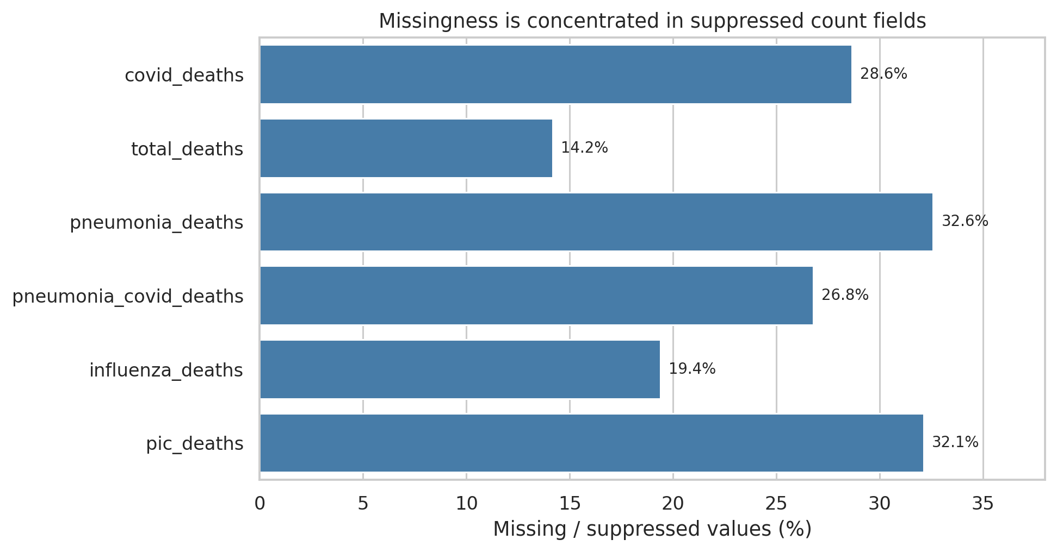
Figure 1. Percentage of values missing in each count measure. All missing count cells occur on privacy-footnoted rows.
Technically, this is a horizontal bar chart with count-field names on the y-axis and missing percentage on the x-axis. The analytical point is that suppression is uneven by measure: pneumonia and the combined P/I/C field lose roughly one-third of values, while total deaths lose about one-seventh. A complete-case analysis across all six fields would therefore discard a large and non-random share of smaller cells.

Figure 2 — Jurisdiction-level high-count flags
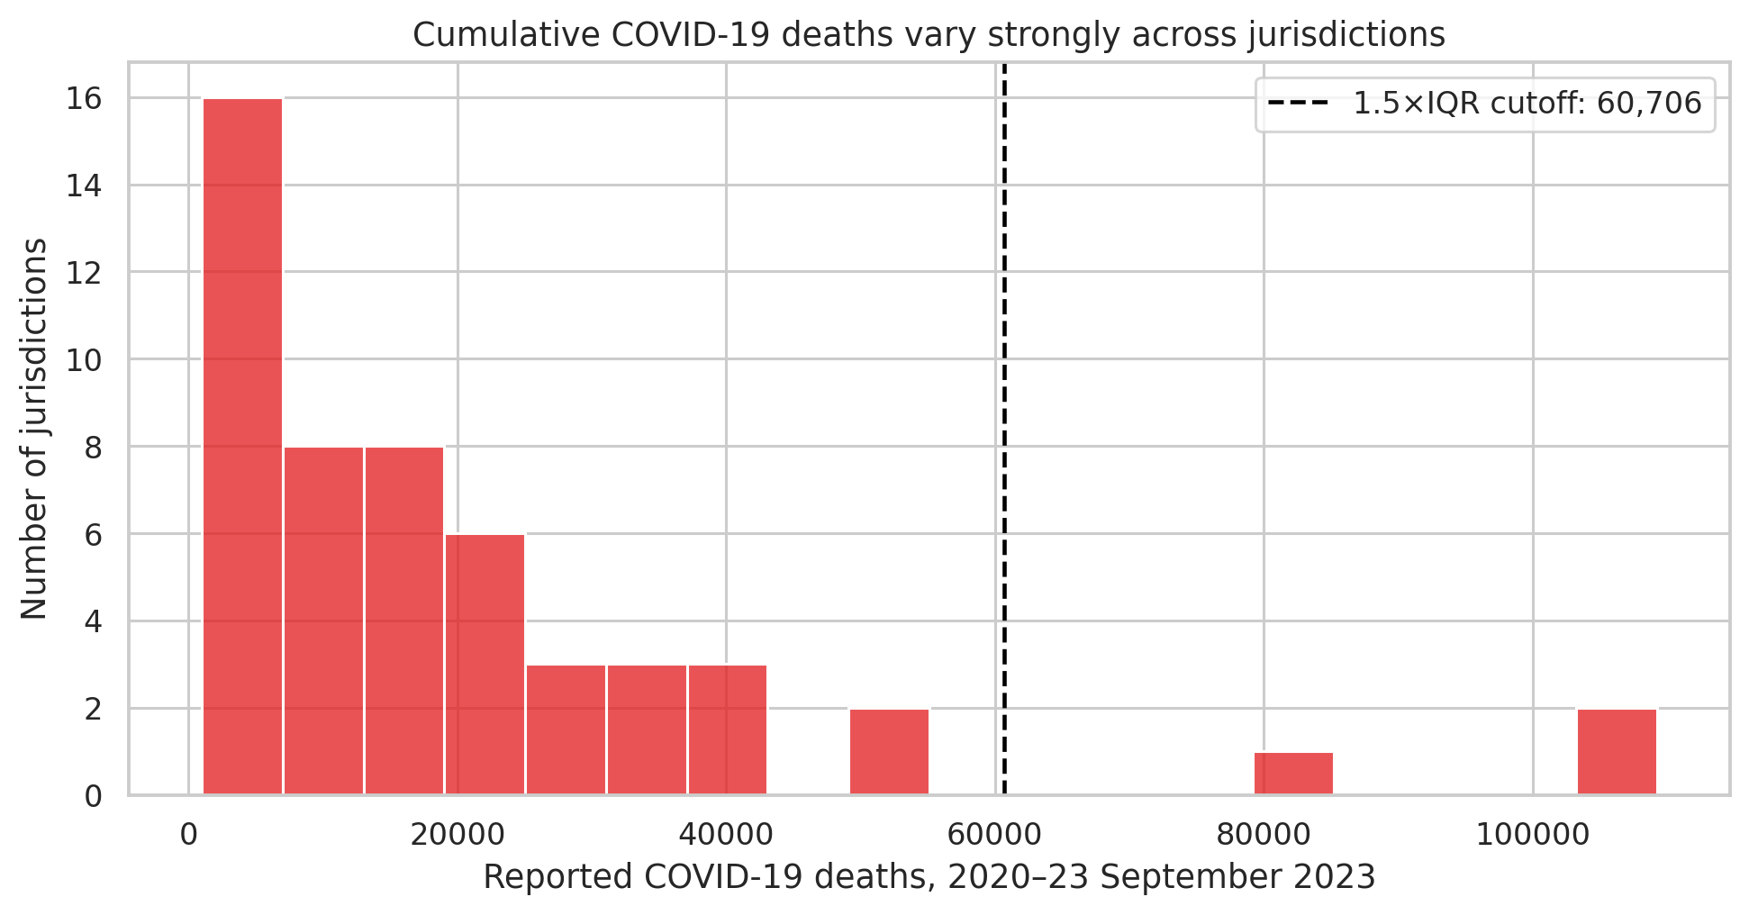
Figure 2. Distribution of cumulative COVID-19 deaths across 52 non-overlapping jurisdictions, with the 1.5×IQR cutoff.
Technically, the histogram uses one cumulative All Sexes, All Ages record per state/DC/Puerto Rico and marks 60,705.625 with a dashed line. Analytically, the right tail is expected in count data because jurisdictions differ greatly in population. The chart supports keeping California, Florida, and Texas and using log transformations or scale-free features in later modeling instead of deleting the tail.

8. Challenges and How They Were Handled
Dataset-specific challenge | Why it matters | Resolution
Comma-formatted counts and mixed inferred types | Arithmetic can fail or silently skip text values. | Load as strings; strip commas only in documented count fields; cast to Float64.
Suppression presented as blanks | Zero-fill would undercount small cells and bias small jurisdictions. | Keep NaN and add measure-specific suppression flags.
Structural Year/Month blanks | Dropping all incomplete rows would delete valid annual and cumulative records. | Validate missingness against Group instead of blanket deletion.
Overlapping age categories | Adding every age row would double-count deaths. | Preserve source rows but define a mutually exclusive analytical age scheme.
Aggregates mixed with components | United States, All Sexes, and All Ages totals can be counted with their subgroups. | Require an explicit grain filter before every aggregation.
Large valid counts resemble statistical outliers | Automatic trimming would erase real burden. | Flag within a coherent grain, inspect context, and retain.
Final month/year is partial | Trend and model targets would be artificially low. | Add is_partial_period and exclude it in complete-period analyses.
Table 4. Concrete cleaning problems and resolutions.

9. Discussion
The main preprocessing decision was to preserve uncertainty rather than hide it. Suppressed values are interval-censored: they are known to lie from 1 to 9, but the exact count is unavailable. Keeping NaN means a later user must make an explicit modeling decision. For a sensitivity analysis, 1, 5, and 9 can serve as lower, midpoint, and upper scenarios; none should replace the official clean value silently.
Outlier handling has a similar practical consequence. Removing California, Florida, and Texas would improve the symmetry of a plot but damage the question the dataset can answer. For count prediction, a log1p target, robust loss, population denominator, or standardized profile is more defensible. For reporting totals, the original count must remain.
The approach is limited by the source. These are provisional aggregate counts by jurisdiction of occurrence, not individual records. The file supplies no population denominators, testing volume, vaccination, comorbidities, or exposure data. COVID-19 share of all deaths is descriptive and is not a population mortality rate. Because the publisher stopped updating this table after 27 September 2023, it cannot support current surveillance without a newer CDC source.
If cleaning were skipped or done badly, downstream effects would be concrete: zero-filled suppressions would make small cells look disease-free; overlapping age bands would inflate totals; September 2023 would appear as an abrupt decline; random row splitting could leak the same time pattern into training and testing; and removing high-count states would produce models that work only for small jurisdictions.

10. Conclusion
I converted a 137,700-row, 16-column CDC extract into a 25-column analysis-ready master table while retaining every source record. The workflow parsed dates and counts, distinguished structural blanks from privacy suppression, marked 5,508 partial-period rows, validated domain relationships, documented overlapping categories, and retained three plausible high-count jurisdiction outliers.
The next step is exploratory analysis on fixed, non-overlapping slices of the cleaned data. Week 2 will use complete monthly periods, one sex level at a time, and a mutually exclusive age sequence so that every plotted number has a defensible denominator and grain.

11. References
- Centers for Disease Control and Prevention, National Center for Health Statistics. Provisional COVID-19 Deaths by Sex and Age. Dataset page: https://data.cdc.gov/National-Center-for-Health-Statistics/Provisional-COVID-19-Deaths-by-Sex-and-Age/9bhg-hcku
- CDC data download used for source verification: https://data.cdc.gov/api/views/9bhg-hcku/rows.csv?accessType=DOWNLOAD
- CDC WONDER provisional mortality access noted by the publisher as the successor source: https://wonder.cdc.gov/mcd-icd10-provisional.html
- McKinney, W. pandas: Python Data Analysis Library. https://pandas.pydata.org/
- Harris, C. R. et al. (2020). Array programming with NumPy. Nature, 585, 357–362. https://numpy.org/
- Waskom, M. L. (2021). seaborn: statistical data visualization. Journal of Open Source Software, 6(60), 3021. https://seaborn.pydata.org/
- Pedregosa, F. et al. (2011). Scikit-learn: Machine Learning in Python. Journal of Machine Learning Research, 12, 2825–2830. https://scikit-learn.org/
- Hunter, J. D. (2007). Matplotlib: A 2D Graphics Environment. Computing in Science & Engineering, 9(3), 90–95. https://matplotlib.org/

